PROJECT REPORT

TITLE NAME: Tracing the growth of global community : a Population forecasting analysis

1. INTRODUTION:

1.1. OVERVIEW:

During the 20th century alone , the population in the world has grown from 1.65 billion to 6 billion. Population in the world is , as of 2022 ,growing at a rate of around 0.84% per year. The current population increase is estimated at 67 million people per year.

World population will continue to grow in the 21st century . World population has doubled (100% increase) in 40 years from 1959(3 billion) to 1999(6 billion). The latest world population forecasting indicates that world population will reach 10 billion persons in the year 2057.

1.2. PURPOSE:

The main purpose of forecasting population is to provide an estimate of the future population as an common framework for use in planning , policy formation and decision making in number of different fields.

2.PROBLEM DEFINITION: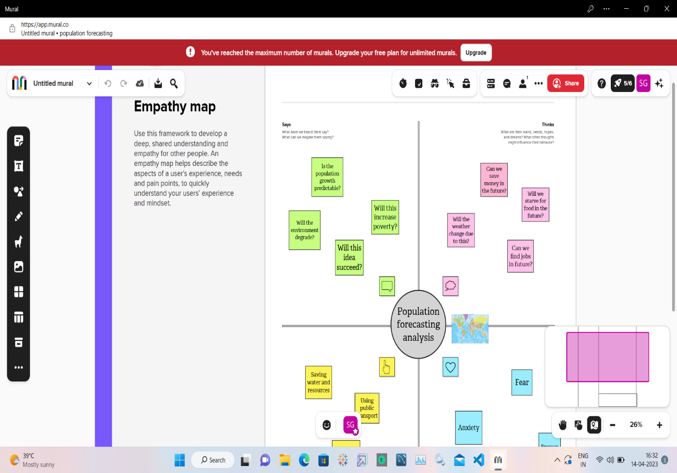

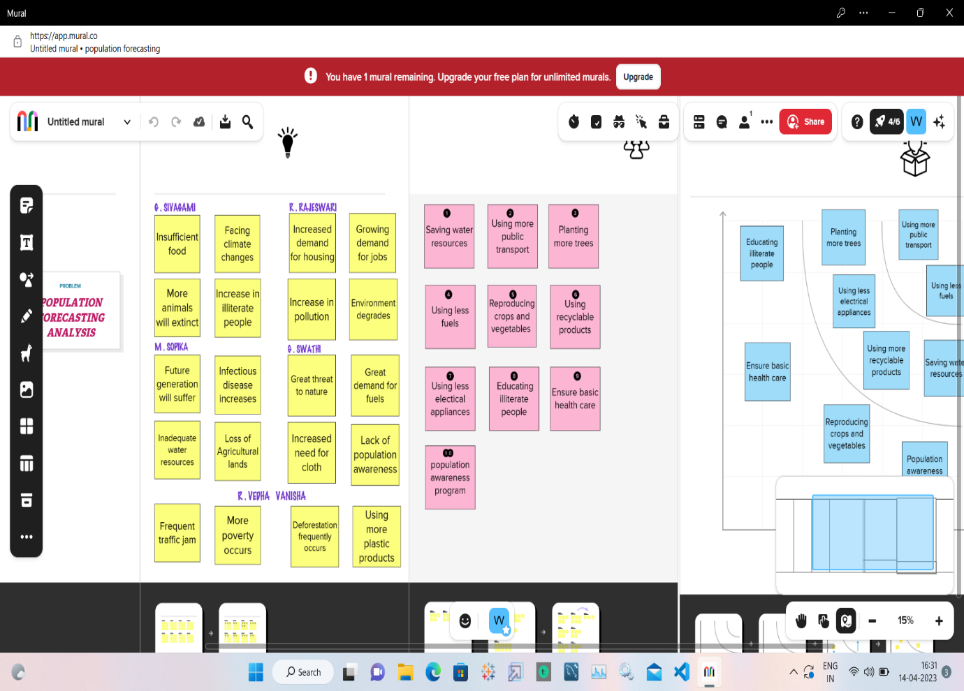

3. RESULT:

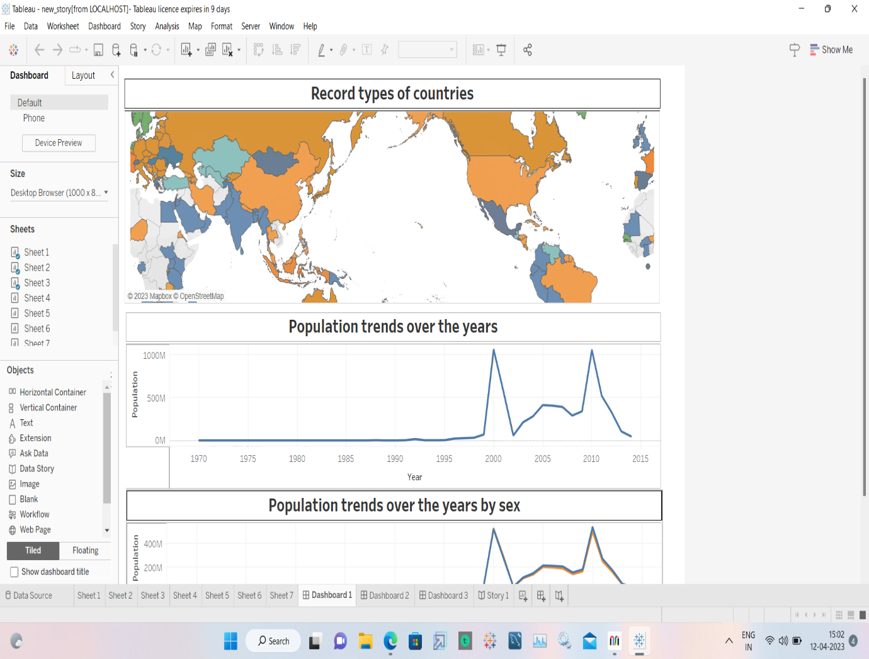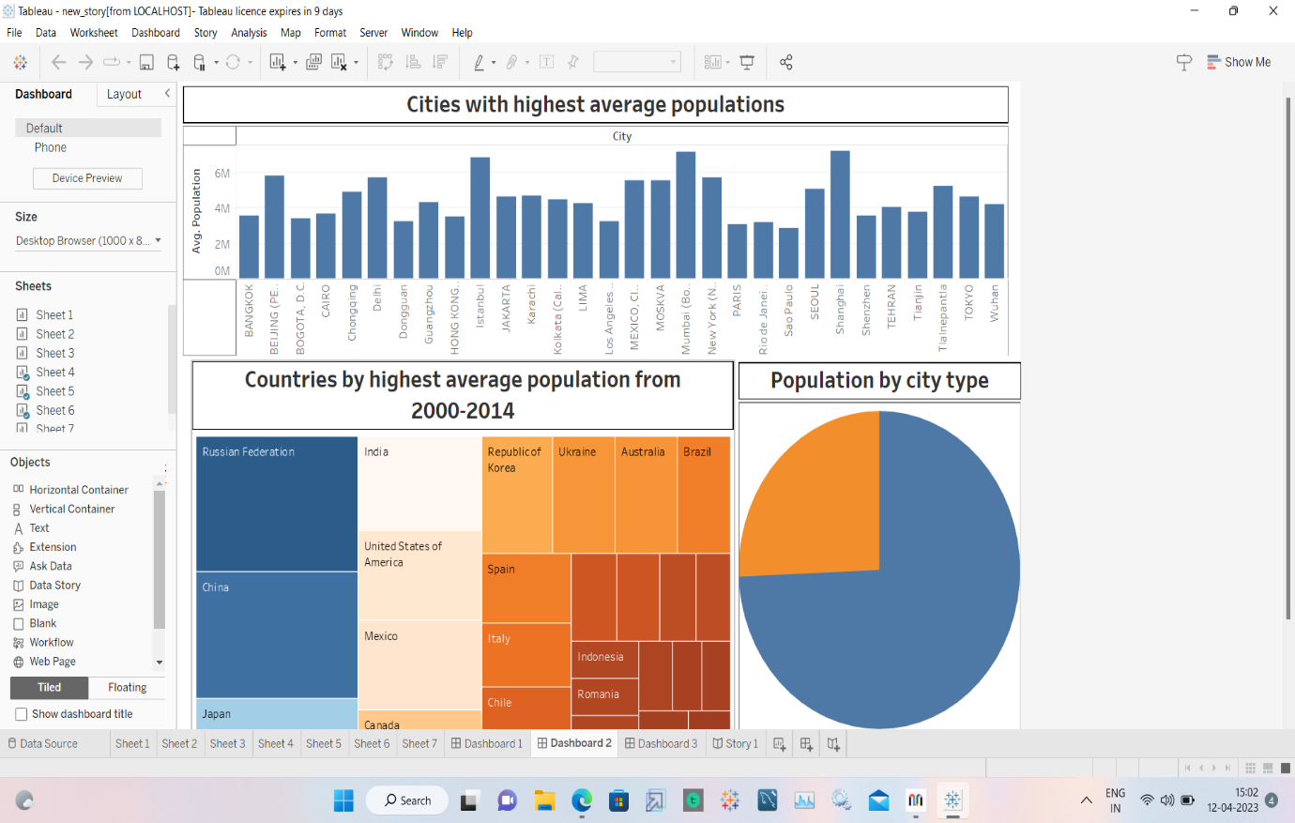

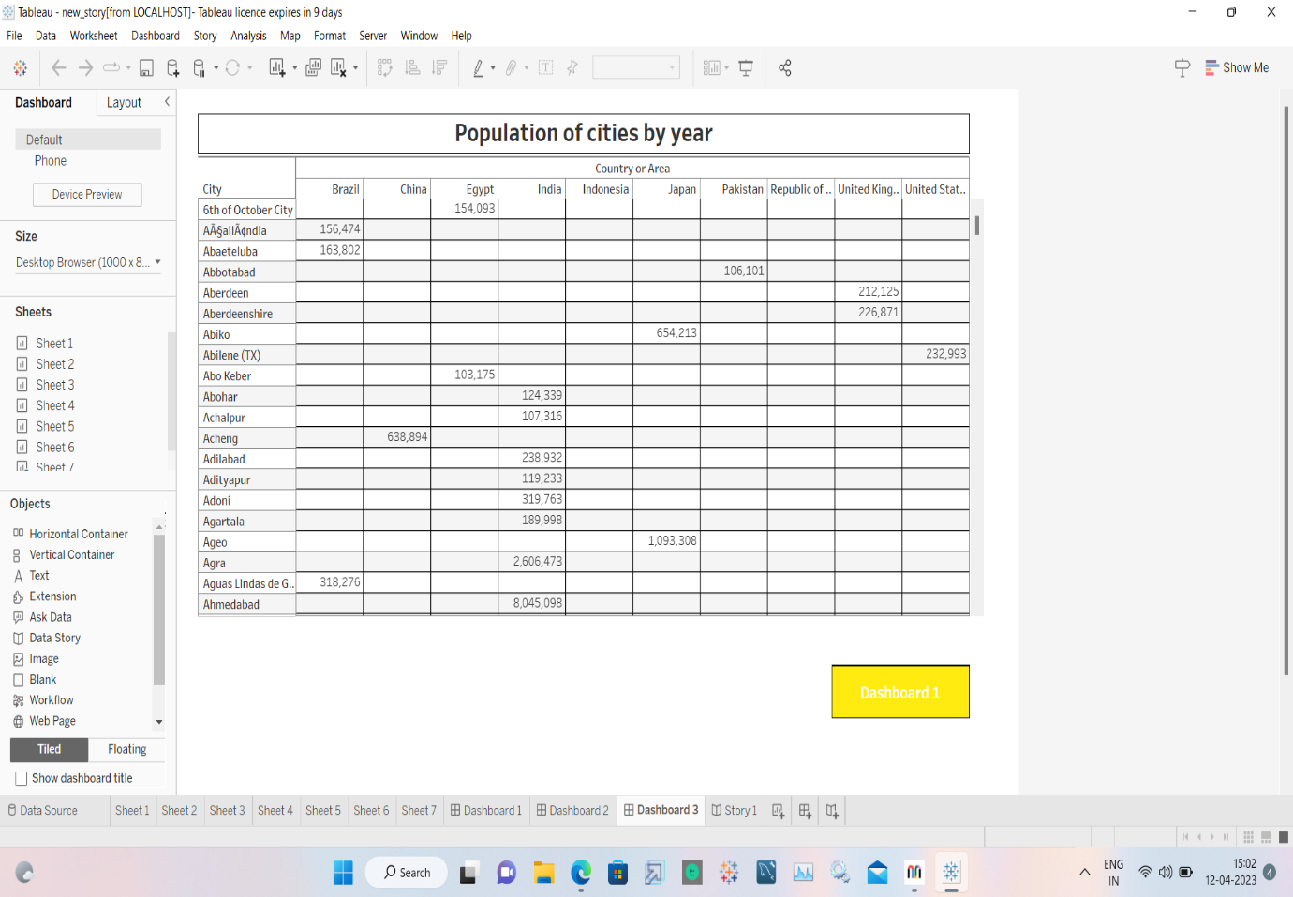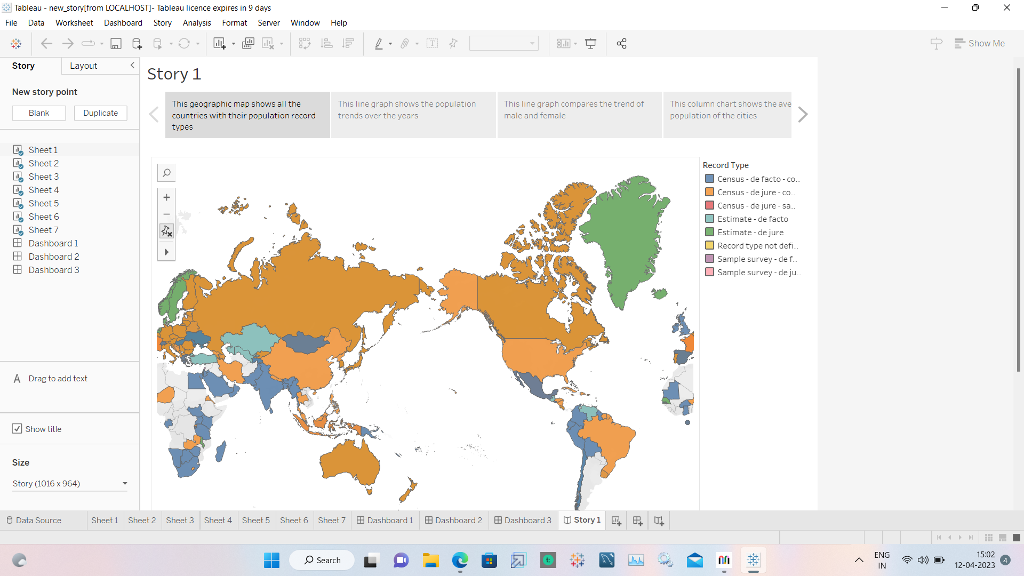

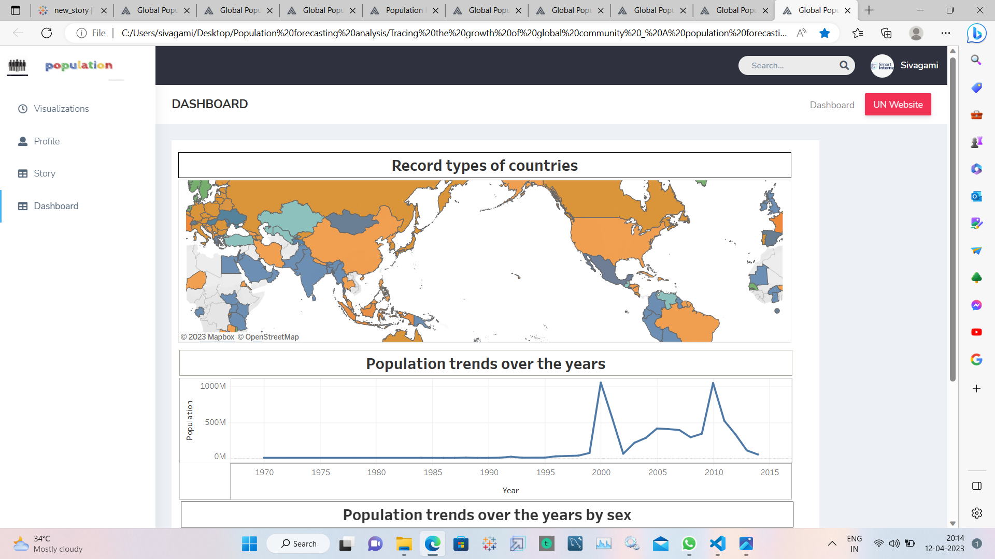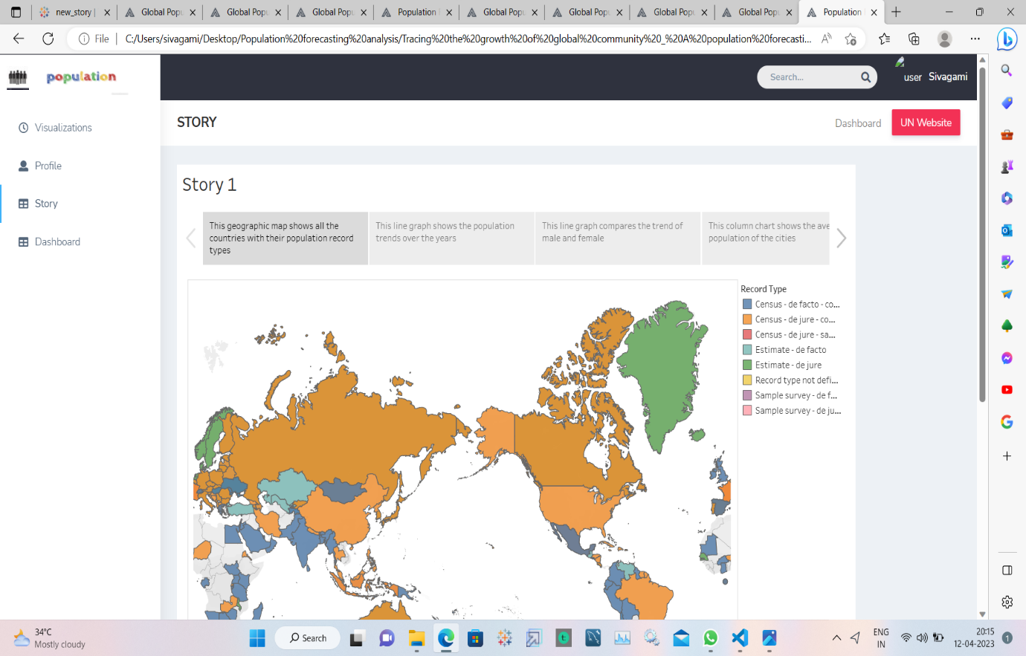

4. ADVANTAGES & DISADVANTAGES:

4.1. ADVANTAGES:

* Population forecasting helps to reduce risks and make better financial decisions.
* This forecasting is used for wide variety of planning.
* This forecasting is used for policy making.

4.2. DISADVANTAGES:

* Population forecasting cannot predict decreasing in population.
* This forecasting requires large number of observations covering a long period.
* These forecasts are never accurate.

5. APPLICATIONS:

* Population forecasting are used to produce forecasts of expenditure for benefits and pensions and as a key input for analysis on policy areas such as extending working lives.
* This forecasting are used to inform business development and other local area planning.
* This forecasting informs the allocation of resources from central government to local areas.

6. CONCLUSION:

This project gives a picture of what the future size and structure of the population by sex and age might look like. It is based on knowledge of the past trends , and for the future , on assumptions made for three components : fertility , mortality and migration.

7. FUTURE SCOPE:

* Population forecasting provide the base for other products such as subnational projections (SNPP) and martial status projections.
* This forecasting helps to estimate the labour forces in various regions.
* This forecasting benefit sociological research , such as providing data about sex ratio or age ratio.

PRESENTED BY

G . SIVAGAMI (leader) ,

R . RAJESHWARI ,

M . SOPIKA ,

G . SWATHI ,

R . VEDHAVANISHA .